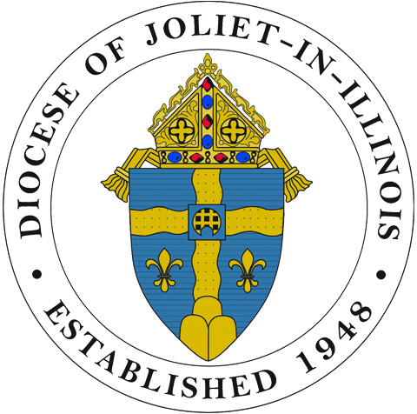 SEMINARIAN CARDS 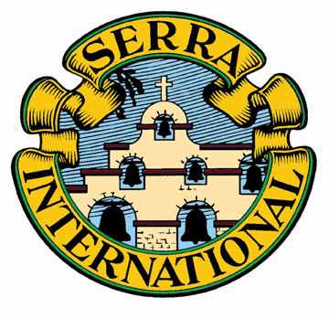
2018 - Diocese of Joliet - 2019
Remember and pray for our seminarians.

Share the cards with:
- students in parish schools & religious education
- parishioners during National Vocation Awareness Week (Nov. 4-10, 2018) or anytime
- family and friends
[Cards are 2¾” x 4¼” two-sided in full color)

ORDERING INFORMATION

39 cards (one of each seminarian + Fr. Steven Borello) @$7.00/deck _____ deck(s) $________
25 cards of _____________________ @$6.00/pack _____ pack(s) $________
Seminarian Name
25 cards of _____________________ @$6.00/pack _____ pack(s) $________
Seminarian Name
TOTAL $__________
(Shipping included)

- Submit orders to: serraclubdc@outlook.com, 630-917-7580
- An invoice will be mailed with order unless payment is received in advance.
- Make check payable to: Serra Club of DuPage County (Mail to same, attn: G. Carr,
320 Browning Court, Wheaton, IL 60189 if invoiced.)

NAME________________________ ORGANIZATION____________________________

ADDRESS__________________________ CITY______________________ ZIP__________

EMAIL_____________________________________ PHONE________________________

The Seminarian Cards are produced and distributed by the Serra Club of DuPage County
with assistance from the Diocese of Joliet Vocations Office.
www.serradupage.org

